Name: _________________

Date: __________________

**Warm Up 1.2 SHOW YOUR WORK!!!**

Solve the following problems by hand, use a graphing calculator to check:

1. Consider the function $f(x)=x^2-6x+3$ and use to evaluate:

2. Use the graph of the function $y=f(x)$ to answer the questions:

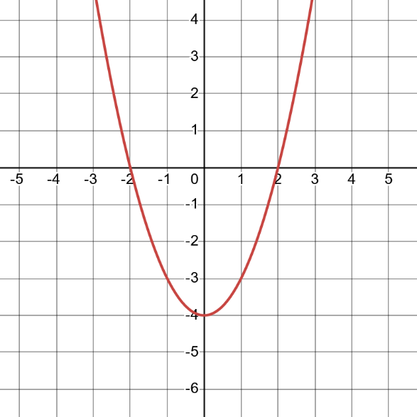

a) Find the domain and range in interval notation and set notation.

b) Find the intercepts.

c) Evaluate $f\left(-1\right), f\left(2\right), f(1)$

d) For what x value(s) is $f\left(x\right)=-3$?